Blockchain Assignment 2
- What is the nonce value? How does it affect acceptance of blocks in blockchain?
- Nonce is “Number used only once” is umber added to hashed block in blockchain
- It is referred to first number miner needs to discover before solving for block
- Once the mathematical computations are solved by the miner, they are gifted cryptocurrency for their time and skill.

- What is the condition to verify that a particular block has been mined? How can other nodes identify this?

When block is mined successfully, hash will start with 0 and number of zeros will denote the difficulty of mining technique

- How does bitcoin blockchain ensure an immutable ledger? Demonstrate
with the help of an example.
When block is mined successfully, hash will start with 0 and number of zeros will denote the difficulty of mining technique
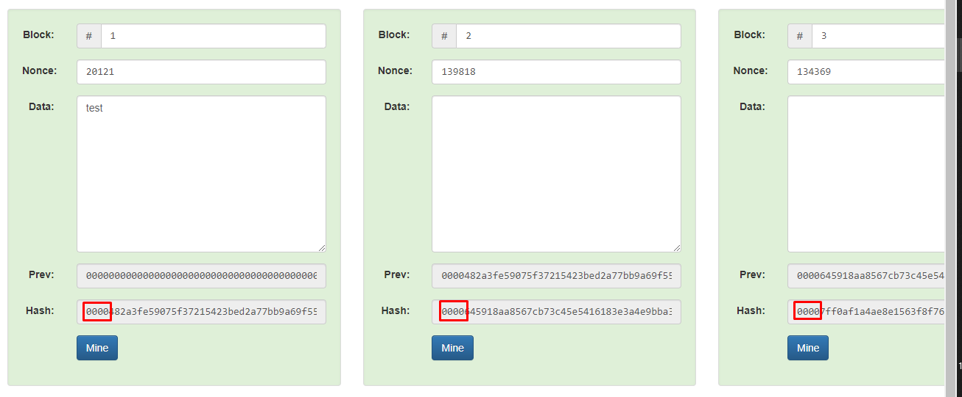
Blockchain is immutable ledger, when person is trying to manipulate or hack blockchain, node which are affected will change hash and following nodes hash also changes, which helps peers in distributed network to identify, node is being manipulated
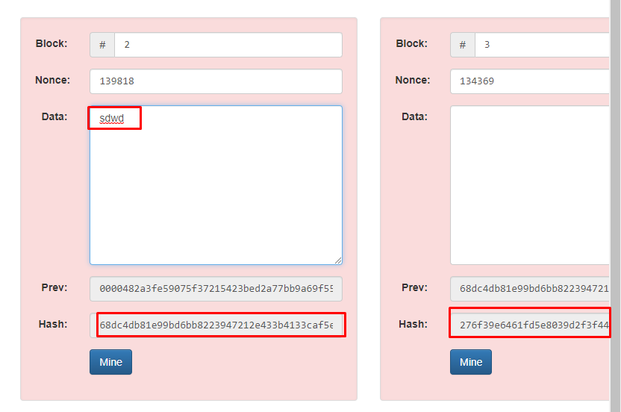
- What is the difference between centralised vs decentralised blockchain?
Centralised –
- It has central authority to control
- Single point of failure
- High chances of fishing attack or hacking
- High chances of personal data breech
Decentralised:
To overcome above disadvantages, Web 2 has moved to decentralised network
Instead of single server, multi-server is setup depends on geographical location, if one region is affected, it won’t affect the complete server
- How does decentralised and distributed blockchain ensure that the longest chain is the honest chain in the network?

Lonest chain is what peer nodes from blockchain network as valid version of blockchain
In proof of work states that longest chain not only serves proof of sequence of events, but proof that is came from largest pool od CPU power

